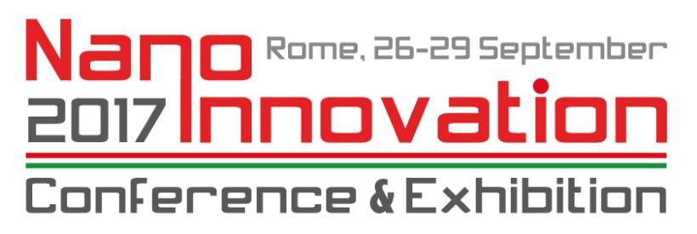

NANOINNOVATION 2017 PROCEEDINGS APPLICATION FORM

Please return this form, properly signed, by email to
marco.rossi@nanoitaly.it and proceedings2017@nanoinnovation.eu
not later than November 30, 2017.

Corresponding AUTHOR DETAILS
Name:

Surname:

Company/University/Research Centre:

E-Mail:

Acceptance of the deadline for manuscript submission: 15 January 2018 YES
NO (in this case, Please indicate another possible date:

TITLE:

Authors and Affiliation:

ABSTRACT (max 1500 characters, including spaces)

